**Characters**

Cyborg Robber (Jeremy Su)

* Very mobile robber
* Slim limbs, cyan hair
* Main Character

Reference Image:

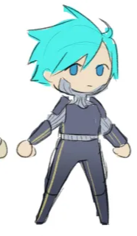

Drones (Bao Nguyen)

* Enemy
* Ranged attacks

Reference Image:

Robots (Rad Nguyen)

* Enemy
* Melee attacks

Reference Image:

WalkieTalkie

* Advisor of the robber/player
* Guides player through the complex

**Assets**

Environment (Justin)

* Futuristic City Layers
* Platforms
* Surrounding Environment
* Tutorial tileset

Interactive Elements (Reann Ubungen)

* ~~Test dummy~~
* ~~Powerup orb~~
* ~~Door (open/close)~~
* ~~Keycards~~
* Weapons (from enemies)

UI - Holograms

* Title Screen
* Pause